Implementation of a Ray Tracer
By: Chloe Atwood
Abstract:
This paper presents a ray tracing renderer developed from the foundations provided in Ray Tracing in One Weekend and the methods taught in the course COMS 3360: Introduction to Computer Graphics at Iowa State University. The implementation includes materials, texture mapping, motion blur, volumetric rendering, and bounding volume hierarchies. Real-time OpenGL visualization improves development workflow, while OpenMP parallelization enables practical render times for complex scenes.
Introduction:
Ray tracing simulates the physical behavior of light by tracing paths from the camera through each pixel into the scene. This project began by following Peter Shirley's Ray Tracing in One Weekend [1], which established the core rendering technology. It was then extended with features from Ray Tracing: The Next Week [2] and even more capabilities inspired by in-class discussion and topics covered in Ray Tracing: The Rest of Your Life [3] and Physically Based Rendering: From Theory To Implementation [4].
The final implementation includes spheres, triangles, quads, and triangle mesh loading as well as diffuse, specular, dielectric and emissive materials. Other features included in this implementation are image-based and procedural textures, motion blur, volumetric rendering, normal interpolation, environment/cube mapping, a BVH acceleration structure, OpenMP parallelization, and an OpenGL preview window that provides real-time visual feedback during the rendering of the image.
Core Rendering System:
Ray-Object Intersections:
The renderer implements intersection equations for spheres, triangles, and quads. Spheres use the standard quadratic equation solution. Triangles use the Möller-Trumbore algorithm, which computes the barycentric coordinates. Quads project rays onto their plane and test rectangular bounds.
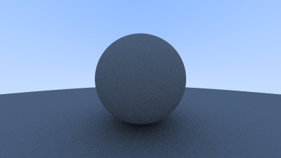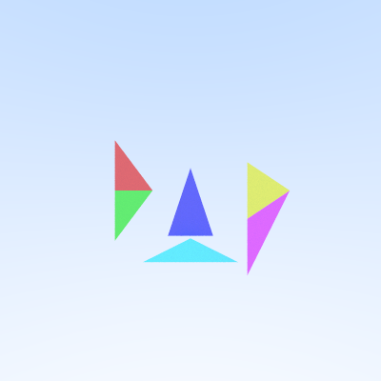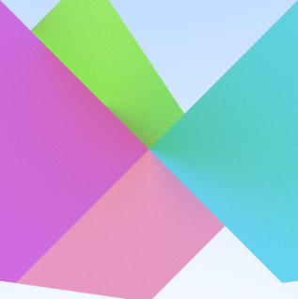
Triangle meshes are loaded from OBJ files using tinyobjloader [10], with each triangle maintaining references to vertex data for normal interpolation and texture mapping.
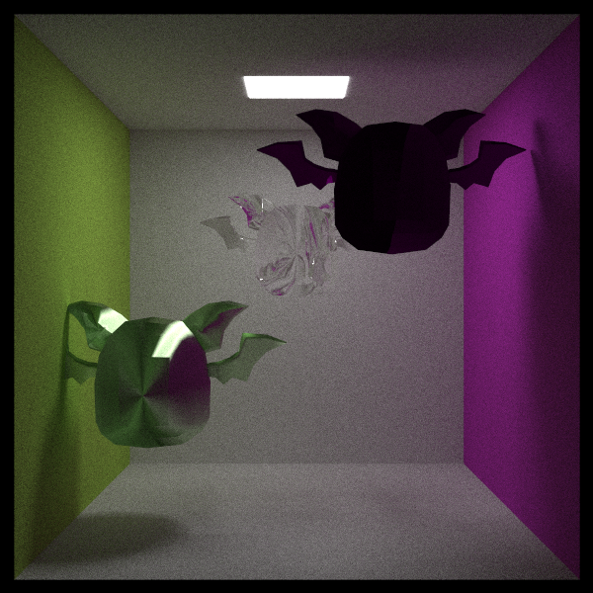
Camera System:
The camera system uses look-from, look-at, and up vectors to define position and orientation, with the field of view controlling the viewing frustum. Defocus blur simulates a real camera lens by generating rays from random points within a circular aperture directed toward the focal plane, creating a depth of field effect.
Materials:
Diffuse (Lambertian) materials scatter incoming light rays in random directions across the hemisphere above the surface. This creates matte surfaces like paper or unpolished wood.
Specular materials reflect rays like a mirror according to the law of reflection. An optional fuzz parameter adds surface roughness by slightly randomizing the reflected direction, simulating materials like brushed metal.
Dielectric materials like glass and water both reflect and refract light. The implementation utilizes Snell's law to calculate the direction of the refracted ray and applies Schlick's approximation to determine the proportion of light that reflects versus refracts based on the viewing angle. This handles effects like total internal reflection when light tries to exit at steep angles.
Emissive materials don't scatter light at all. They instead emit light by directly returning a color value. This allows any object to act as a light source, creating area lights that produce soft, realistic lighting.
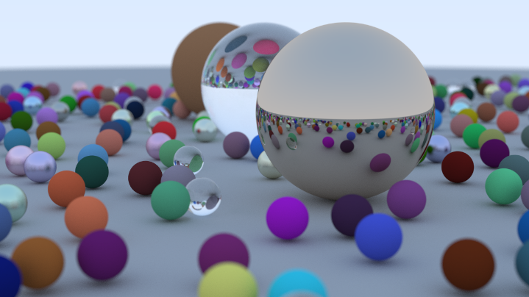
Advanced Rendering Features:
Textures:
The stb_image library [9] loads image textures in common formats like PNG and JPG. When a ray hits a surface, texture coordinates determine which pixel of the image to sample for the surface color. Bilinear filtering smooths the result by blending nearby pixels.
Procedural textures generate patterns using math instead of images. The implementation utilizes Perlin noise, which generates smooth, random patterns useful for simulating textures such as marble or wood grain. The noise function takes the 3D hit point as input, allowing the pattern to wrap naturally around objects without seams.
Spheres use spherical coordinates for texture mapping, while triangles interpolate texture coordinates from their three vertices using barycentric coordinates.
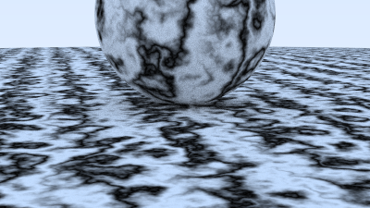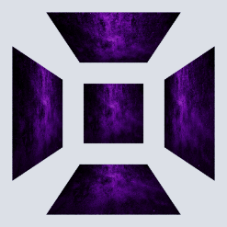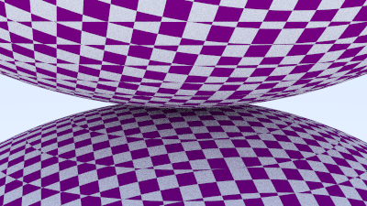
Motion Blur:
To simulate motion blur, objects can move during the "camera shutter" time. Each ray is assigned a random time between 0 and 1, representing the point during the exposure at which it was fired. When the ray hits a moving object, the object's position is calculated for that specific time. Fast-moving objects appear as streaks while stationary objects remain sharp.
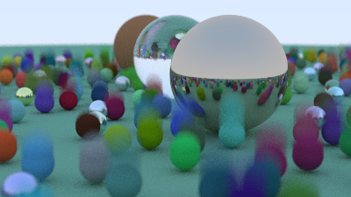
Volume Rendering:
Volumetric effects like fog work differently from solid surfaces. Instead of a hard boundary, rays traveling through fog might scatter at any point along their path. The implementation defines a fog volume with a constant density. As a ray travels through this volume, the probability of scattering decreases exponentially with distance. When scattering occurs, the ray bounces in a random direction, creating the soft, diffuse look of fog or smoke.
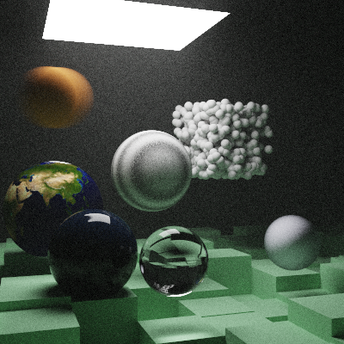
Normal Interpolation:
Triangle meshes naturally have flat faces, which creates a faceted appearance even when trying to represent smooth surfaces. Normal interpolation fixes this by storing a normal vector at each vertex that points in the "ideal" direction for a smooth surface. When a ray hits anywhere on the triangle, the three vertex normals are blended together using barycentric coordinates to produce a smooth normal. This makes curved objects appear smooth, even when built from triangles.
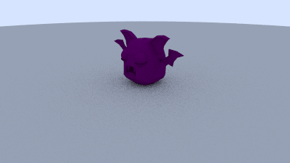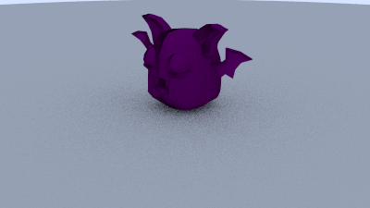
Environment/Cube Mapping:
Environment maps provide lighting and reflections from the surrounding world. The implementation uses an equirectangular image (like an unwrapped sphere) that captures a full 360-degree view. When a ray doesn't hit any object in the scene, instead of returning black, it converts its direction into texture coordinates to look up a color from the environment map. This provides realistic sky lighting and allows reflective objects to show their surroundings.
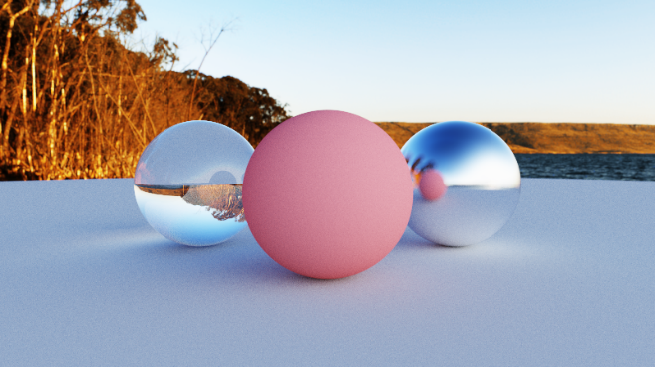
High Dynamic Range Images:
Regular images store colors as values from 0 to 255, but real light has a much wider range of intensities. Think about how the sunlight is drastically brighter than indoor lighting. HDR images store floating-point values that preserve these brightness relationships. The renderer keeps all calculations in HDR, only converting to regular values at the very end using tone mapping. This is especially important for environment maps, where maintaining the relative brightness differences creates realistic lighting.
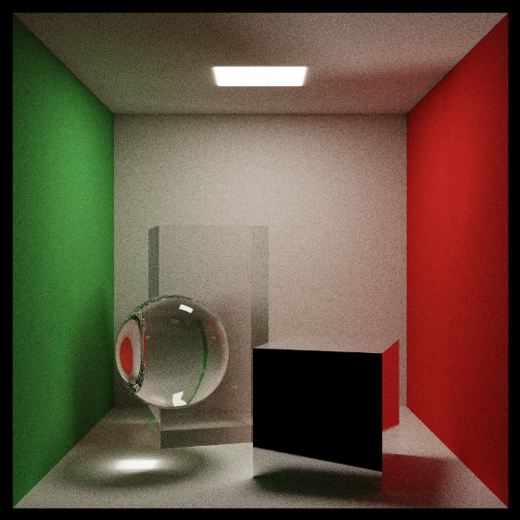
Optimization and Acceleration:
Bounding Volume Hierarchies (BVH):
Without optimization, the ray tracer must test every ray against every object in the scene. That is a lot of intersections, and it takes a long time to get through all of them.
BVH organizes objects into a tree where each node stores an axis-aligned bounding box (AABB) containing all objects in its subtree. To build it, the objects are sorted along their longest axis and split in half. When testing a ray, if it misses a node’s bounding box, all objects inside that box can be skipped. This reduces the average number of tests for every object. This typically provides a 10-100x speedup depending on scene complexity.
Parallelization:
Modern CPUs have multiple cores that can work simultaneously. Since each pixel can be calculated independently, ray tracing is naturally parallel. OpenMP [6, 7] adds parallelization with a single line of code (`#pragma omp parallel for`) placed before the main pixel generation loop. This automatically distributes pixels across all available CPU cores or the number of CPU cores specified by the programmer. The default amount in this ray tracer is the number of CPU cores on the device minus 3, leaving cores available for the operating system and other tasks
Real-Time Visualization with OpenGL:
Traditional ray tracing requires waiting for the entire image to finish before seeing results. The OpenGL preview system solves this by displaying the image as it renders. Using GLFW [11] for window management, the current state of the image is periodically uploaded to a texture and displayed on screen. As more samples accumulate, the image gradually becomes clearer and less noisy.
Results:
The ray tracer successfully produces photorealistic images with a variety of effects. Example scenes demonstrate combinations of different materials (metal, glass, diffuse), both procedural and image-based textures, motion blur on moving objects, fog volumes creating atmospheric depth, complex triangle meshes loaded from OBJ files, environment map lighting, and depth of field focusing attention on specific subjects.
Conclusion:
This project demonstrates that starting from basic ray tracing concepts, a renderer with professional features can be built incrementally. Each feature builds on previous work: materials depend on ray intersections, textures extend materials, BVH accelerates intersections, and so on. The modular design made it straightforward to add new capabilities without requiring the restructuring of existing code.
The most impactful additions were BVH acceleration and parallelization, which transformed render times from hours to minutes. The OpenGL preview window significantly improved the development process by providing instant feedback, rather than relying on blind iteration.
Interesting Images:
Final Renders:
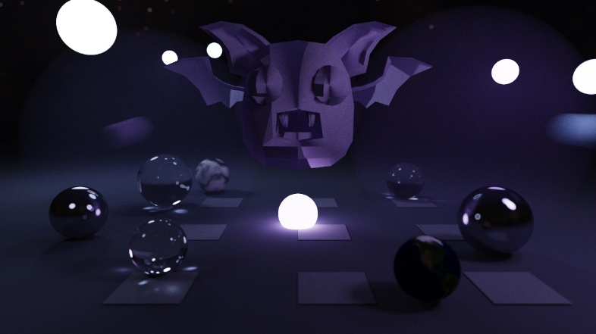
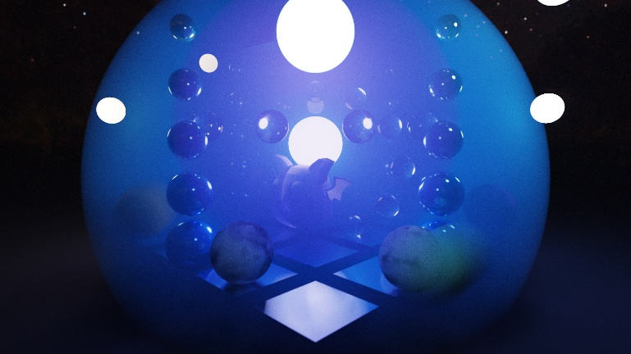

Miscellaneous Renders Throughout the Project:
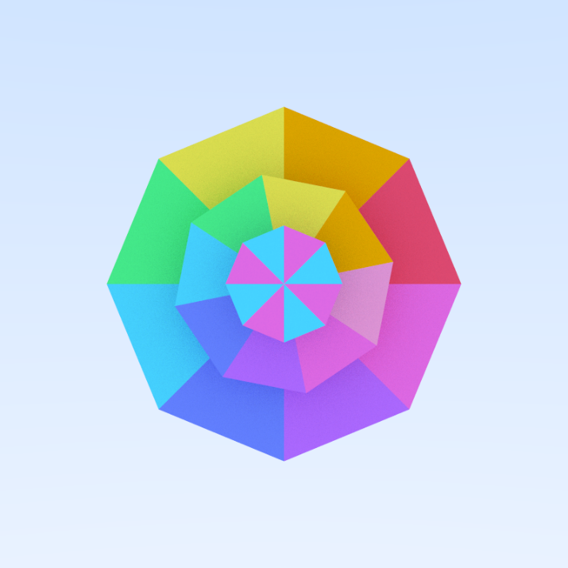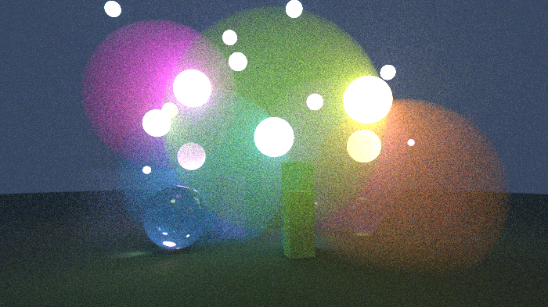
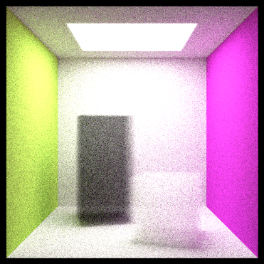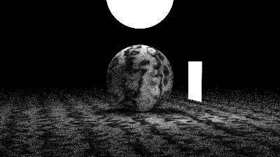

References:
Books:
[1] P. Shirley et al., “Ray Tracing in One Weekend,” [Online], https://raytracing.github.io/books/RayTracingInOneWeekend.html (accessed Dec. 2, 2025).
[2] P. Shirley et al., “Ray Tracing: The Next Week,” [Online], https://raytracing.github.io/books/RayTracingTheNextWeek.html (accessed Dec. 2, 2025).
[3] P. Shirley et al., “Ray Tracing: The Rest of Your Life,” [Online], https://raytracing.github.io/books/RayTracingTheRestOfYourLife.html (accessed Dec. 2, 2025).
[4] Matt Pharr, Wenzel Jakob, Greg Humphreys et al., “Physically Based Rendering: From Theory To Implementation,” [Online], https://pbr-book.org/ (accessed Dec. 2, 2025).
Tutorials:
[5] “Introduction,” Learn OpenGL, https://learnopengl.com/Introduction (accessed Dec. 2, 2025).
[6] “OpenMP,” OpenMP, https://www.openmp.org/(accessed Dec. 2, 2025).
[7] “OpenMP,” LLNL HPC Tutorials, https://hpc-tutorials.llnl.gov/openmp/ (accessed Dec. 2, 2025).
Libraries:
[8] “std_write.h” GitHub. [Online], https://github.com/nothings/stb/blob/master/stb_image_write.h (accessed Dec. 2, 2025).
[9] “std_image.h” GitHub. [Online], https://raw.githubusercontent.com/nothings/stb/master/stb_image.h (accessed Dec. 2, 2025).
[10] “tinobjloader.h” GitHub. [Online], https://github.com/tinyobjloader/tinyobjloader (accessed Dec. 2, 2025).
Assets:
[11] “GLFW Download,” GLFW, https://www.glfw.org/download.html (accessed Dec. 2, 2025).
[12] “freepik,” FREEPIK, https://www.freepik.com/ (accessed Dec. 2, 2025).
[13] “Poly Haven,” Poly Haven, https://polyhaven.com/ (accessed Dec. 2, 2025).
[14] “EXR to PNG converter,” ONLINE-CONVERT, https://image.online-convert.com/convert/exr-to-png (accessed Dec. 2, 2025).

